Develop a test scenario and write some test cases for the following screen shot taken from course portal of UON:

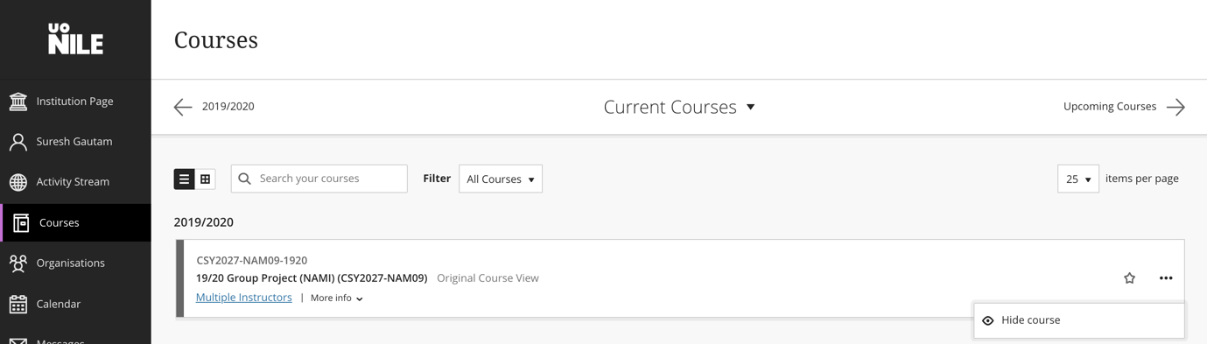

Hint: Refer “Sample Test_Scenario_Cases.xlsx” for sample test scenario and test cases.